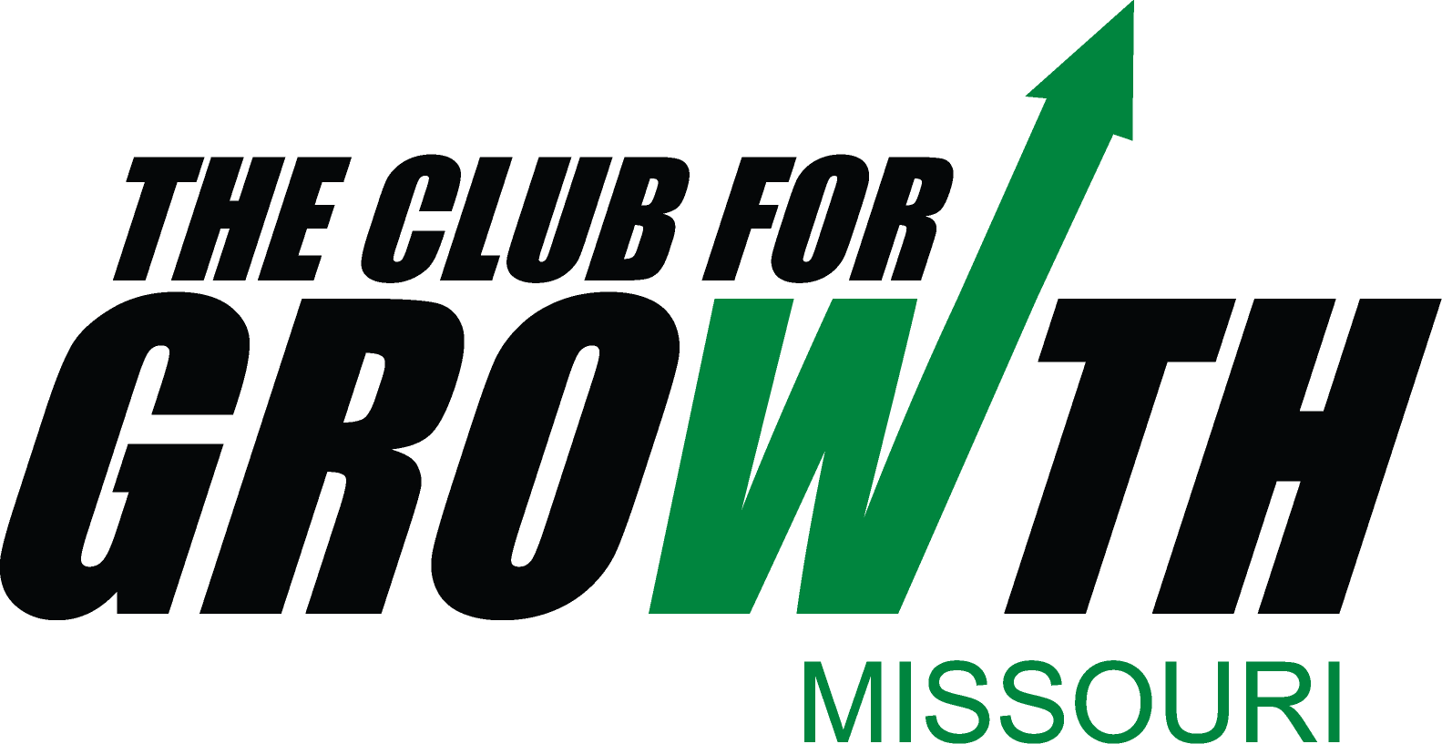
Missouri Club for Growth
Candidate Questionnaire
Election 2010

- Explain your approach to economic growth and development:
Growth works best when government neither favors nor impedes the individual entrepreneur. Therefore, I favor relieving business of make-work regulation. However, I also oppose all the various “incentives” that tilt the table in favor of one business or location over another. Realistically, I recognize that Missouri is in competition with other states for industry, but a low-tax, low-regulation climate should obviate the need for many incentives.

- If elected, would you support efforts by government to regulate personal behavior by raising taxes on items such as alcohol, tobacco, salt, soft drinks, saturated fat etc.? Explain:
NO. Government should have no role in regulating individual behavior that does not infringe on the rights of others.

- If elected, do you pledge to not raise taxes? Yes or No
Comments:
Have you ever seen a Libertarian who favored taxes?

- Do you believe tax credits/incentives to businesses are the correct approach to job development and economic growth? Explain:
No. They favor one business or location over another. Businesses make decisions that may not be in their (or the local) best economic interest. Incentives (as do all taxes) take a certain level of rationality out of the decision process.

- Do you believe in the principles of the FAIR tax? (Elimination of the income tax to be replaced by a sales tax on certain products and services):
Yes, at the Federal level. That makes payment of taxes much more voluntary and prevents much of the favoritism, fear and work associated with the current system. Missouri should not consider it until/unless ebacted at the Federal level.

- What are your feelings regarding State Sovereignty and the 10th amendment?:
The Interstate Commerce Clause has been used to overextend Federal power. As long as the basic rights guaranteed by the first 8 amendments are protected in the states, the Federal government should accept the primacy of states in managing their own affairs.

- In your opinion, how can government best cut wasteful spending?
Eliminate programs best left to lower levels, returning both the responsibility and funding sources to the lowest possible level. Bureaucracy creates waste; the more bureaucracy a program or dollar goes through, the more the waste and petty regulation.

- What are your thoughts on healthcare reform efforts?
Allow doctors to compete, eliminate many of the mandates now in place.

- What unique qualifications or experience do you have that makes you an ideal candidate?
I am independent of the existing power structures and not beholden to any of them. I have operated a small business for over 20 years, am a graduate of the Air Force Academy with an MBA from MU and an additional BS in Agriculture from UCM.

- If elected, what are your top three legislative priorities?:
Stop eminent domain abuse, reform tax credit system, reduce government interference in the lives of our citizens.

- Please provide any additional information below:
Both Democrats & Republicans have failed this country. It’s time to look at liberty-oriented alternatives.
Please return this questionnaire via email or mail by June 30th
melanie@moclubforgrowth.com
Missouri Club for Growth
P.O. Box 2068
Saint Louis, MO 63158-2068

